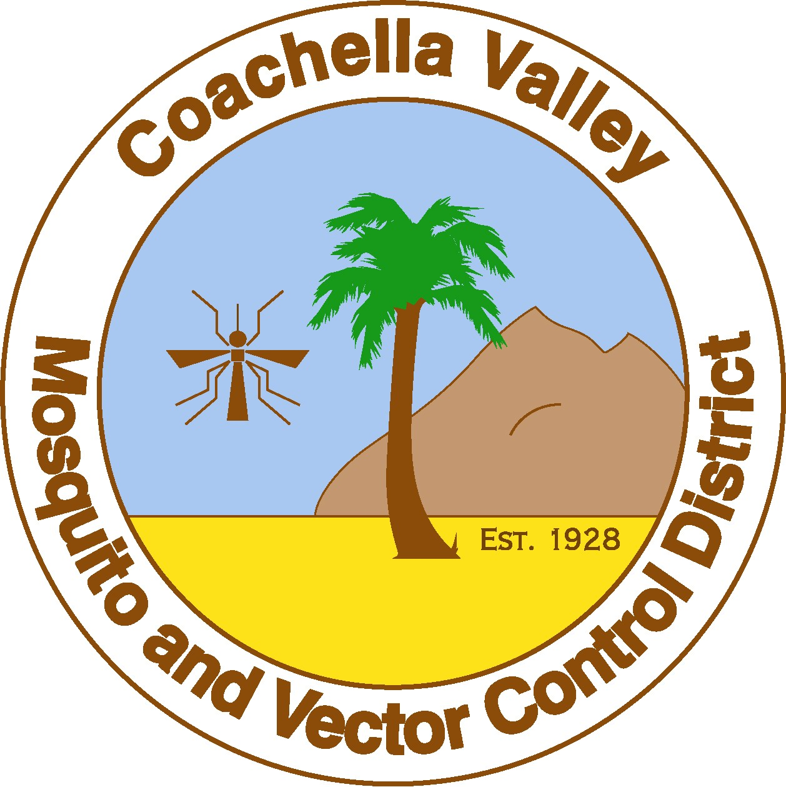
Coachella Valley Mosquito and Vector Control District
43-420 Trader Place • Indio, CA 92201 • (760) 342-8287 • Fax (760) 342-8110
E-mail: CVmosquito@cvmvcd.org • Website: www.cvmvcd.org
Board of Trustees

President
BRUCE UNDERWOOD, Dr. P.H.
Indian Wells

Vice President
SHARON LOCK
Palm Springs

Secretary/Treasurer
GARY HOWELL
Cathedral City

STEVEN HERNANDEZ
Coachella

ALBERT KECK
County at Large

ELLEN TROVER
County at Large

KARL BAKER, JR.
Desert Hot Springs

GENE GILBERT
Indio

ROBERT COX
La Quinta

DOUGLAS WALKER
Palm Desert

CHARLES RICH
Rancho Mirage

BRANKA B. LOTHROP, PhD.
General Manager

PRESS RELEASE

Contact: For Immediate Release:
Jeremy Wittie October 8, 2010
Scientific Operations Manager

Maria C. Kylis
Community Outreach Coordinator
(760) 342-8287 or (888) 343-9399
Email: mkylis@cvmvcd.org
Vector control announces first dead bird positive for west nile vIRUS positive in the valley
INDIO, Ca, October 8, 2010: The Coachella Valley Mosquito and Vector Control District (District) received confirmation from the California Department of Public Health (CDPH) of the first West Nile virus (WNv) positive dead bird. The bird, a northern mockingbird, was found on September 23rd in the Palm Springs area. There will be increase in the District’s adult mosquito surveillance and control measures in this area. The District remains in Emergency Planning mode. Please visit the District website for additional information and the CVMVCD Mosquito-Borne Virus Surveillance and Emergency Response Plan. Currently, the Districts has had 67 mosquito samples, 33 sentinel chickens, and 1 dead bird test positive for WNv.
To date, in California, there have been 62 human cases with one fatality, 1,244 positive mosquito samples, 385 dead birds, and 241 sentinel chickens that have tested positive for WNv.
~MORE~
Page 2
WNv is transmitted to humans and animals through a mosquito bite. Mosquitoes become infected when they feed on infected birds. Most individuals who are infected with WNv will not experience any illness. Young children, the elderly, or individuals with lowered immune systems are more susceptible to WNv.
The District continues its extensive surveillance, prevention, and treatment programs throughout the Coachella Valley and urges residents to help reduce mosquito breeding sources by inspecting their backyards and neighborhoods for standing water sources at least once a week.
Individuals can reduce their risk of mosquito-borne diseases by taking these precautions:
- Avoid outdoor activity at dusk and dawn.
- When outdoors, wear long pants, long-sleeved shirts and other protective clothing.
- Apply insect repellent according to label instructions.
- Make sure that doors and windows have tight fitting screens. Repair or replace screens that have tears or holes.
- Eliminate all sources of standing water on your property that can support mosquito breeding.
- Contact your local mosquito and vector control agency if there is a significant mosquito problem where you live or work.
Contact the Coachella Valley Mosquito and Vector Control District at 760-342-8287 or 1-888-343-9399 to report mosquito problems, request mosquito fish, to report neglected pools or standing water. Service requests can also be submitted online at www.cvmvcd.org .
~END~

